Messert Ethiopia is a non-political, non-profit and non-religious organization that embraces all ethnic groups.

The mission of the organization is to identify currently urgent social problems that affects children in Ethiopia and work towards alleviating
them.

The main task of the organization is fund-raising and finding long-term sponsors for children programs operated by local non-governmental
organizations in Ethiopia.

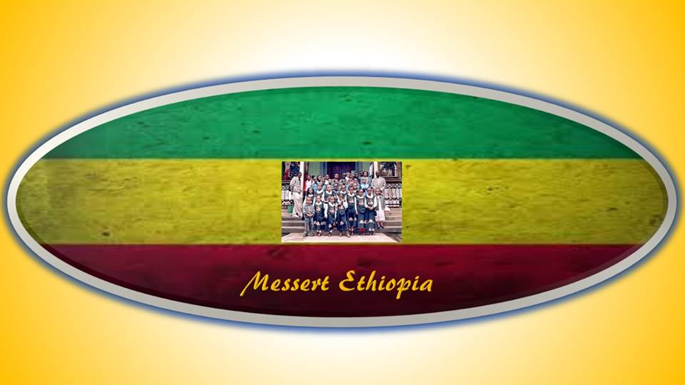
SPONSORSHIP FORM
Please fill the form and email it to us at messertethiopia@gmail.com

Name of sponsor: _________________________________________________________
Address: _________________________________________________________
_________________________________________________________
_________________________________________________________
Phone: _________________________________________________________
E-mail: _________________________________________________________
Name of sponsored child: __________________________________________________
Age: ____________ Female ____________ Male _____________

Sponsor’s contribution:
Period | January - June | July – December | January – June | July - December
Date of payment
Amount paid
Remarks

Messert Ethiopia is working to make a difference in the lives of Ethiopia's children.
Thank you so much for all your support.

